Tracking Form for Compensatory Services due to COVID-19
STUDENT NAME/NUMBER |  |  |  |  |  |  |  |  | GRADE LEVEL
DISTRICT
SCHOOL
EVALUATION DATE |  |  |  |  | IEP DATE |  |  |  | DATE OF BIRTH
CASE MANAGER
Date(s) school physically closed for all students due to COVID-19 or the threat of COVID-19
From |  |  |  | To |  |  |  | Number of School Days
From |  |  |  | To |  |  |  | Number of School Days
 |  |  |  |  |  |  |  | Box 1: Total NUMBER of Days Closed
Date(s) student was at home prior to school closure, and decision to keep student home was due to COVID-19 or the threat of COVID-19

From |  |  |  | To |  |  |  | Number of School Days
From |  |  |  | To |  |  |  | Number of School Days
 |  |  |  |  |  |  |  | Box 2: Total NUMBER of Days at Home
 |  |  |  |  |  |  |  | Total from Box 1 + Box 2
Date(s) school was closed for ESY
From |  |  |  | To |  |  |  | Number of School Days
 |  |  |  |  |  |  |  | Box 3: Total number of Days Closed for ESY
 |  |  |  |  |  |  |  | Total of Box 1+2+3
Date(s) educational services were provided to any or all students during the time periods above
From |  |  |  | To |  |  |  | Number of School Days
From |  |  |  | To |  |  |  | Number of School Days
From |  |  |  | To |  |  |  | Number of School Days
From |  |  |  | To |  |  |  | Number of School Days
 |  |  |  |  |  |  |  | *Total NUMBER of School Days
*NOTE: if your school had “days of no instruction for planning purposes” you need to document that above. So, let’s say a school had instruction from March 30- April 8. Then, the school sent out an email that said “April 9 and 10 will be for planning and no assignments, tests, or instruction will occur on those dates”, then you document from March 30 to April 8 in one of the rows above. Then, the next row will start with April 11.

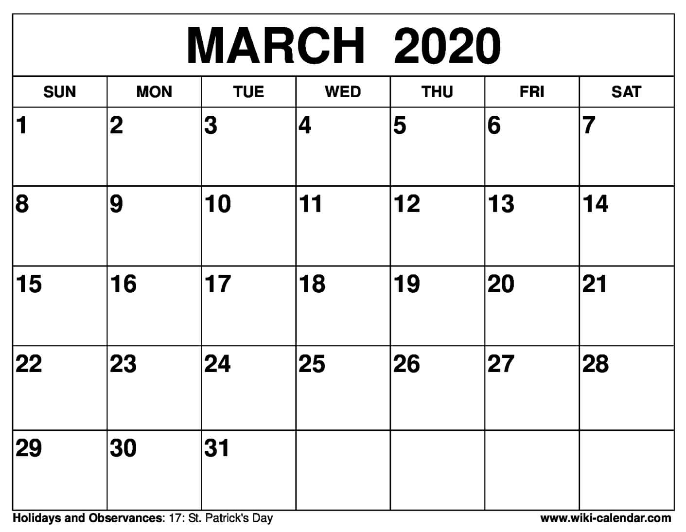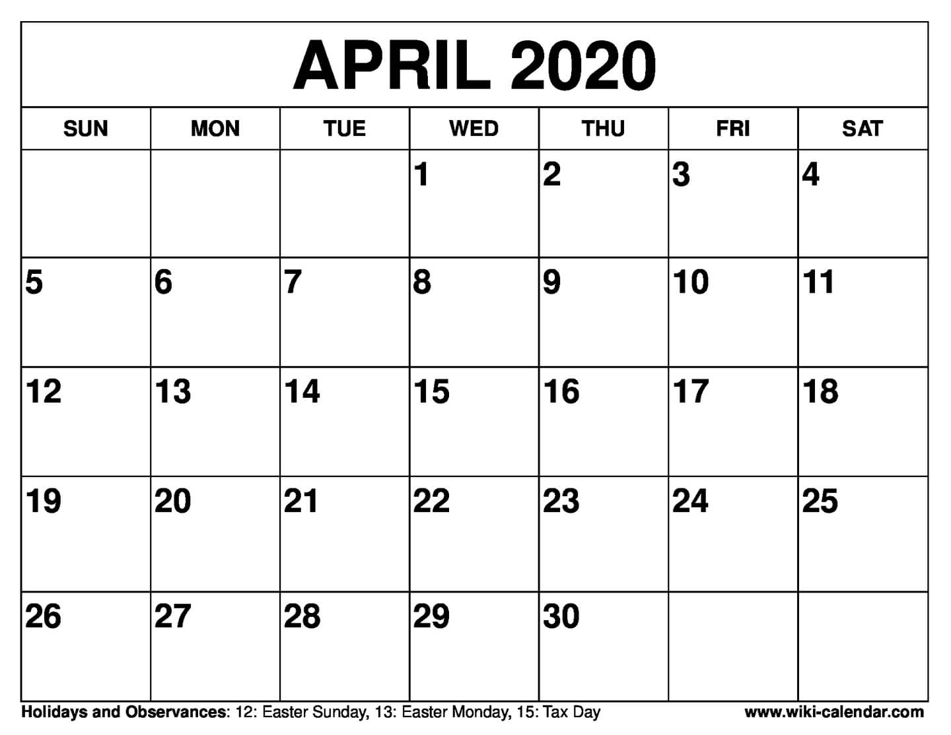
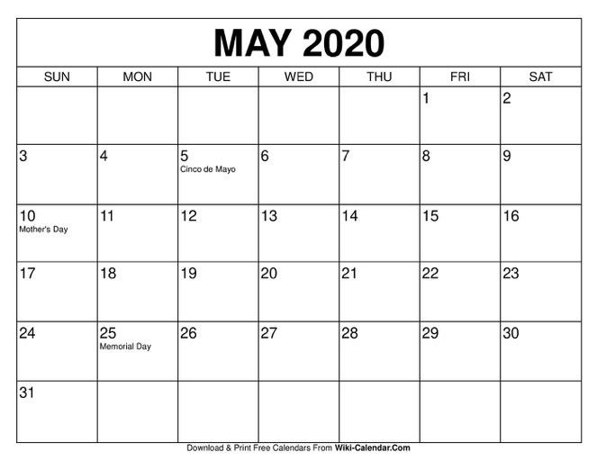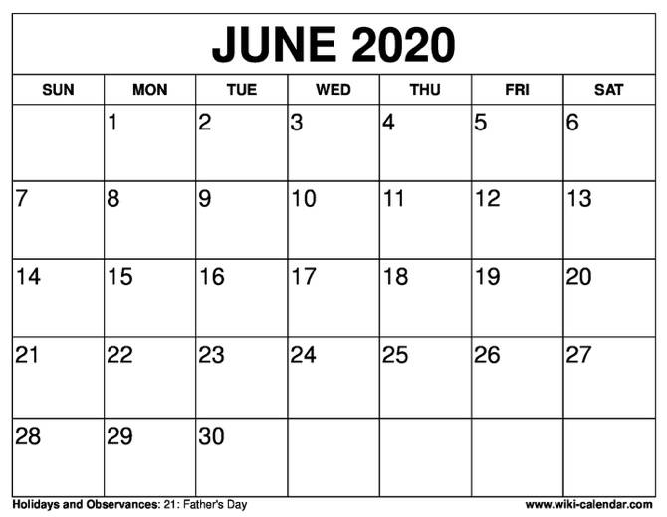

Description of educational services provided by local education authority (LEA) to ALL students at this grade level during the physical closure.

Description of Services to be provided in the student’s annual IEP

Service | Initiation Date | Frequency | Location | Duration | Staff Responsible for Delivering Service
Comments:

Description of IEP Services, considering the student's unique circumstances that could affect distance learning, provided by LEA for this student during the physical closure above. (Use the space below to document IEP services delivered through alternate or additional methods, when feasible, including any accommodations/modifications provided to enable access to instructional materials.)
SERVICES PROVIDED TO STUDENT DURING CLOSURE
Service | Initiation Date | Frequency | Location | Duration | Staff Responsible for Delivering Service
☐ No services provided during closure. Consideration of compensatory services will be done a later date.

EVALUATION TIMELINES
Date evaluation is due |  |  | Due during closure? |  | ☐Yes ☐No
If yes, what is the plan for completion of the evaluation within the required timeline, including the participation of the parent in the process?
Parent agreed to plan? | ☐Yes ☐No | If yes, date and method
IEP TIMELINES
Date IEP is due |  |  | Due during closure? |  | ☐Yes ☐No
If yes, what is the plan for completion of the IEP within the required timeline, including the participation of all IEP team members, including the parent (and student if appropriate)?
Parent agreed to plan? | ☐Yes ☐No | If yes, date and method
PARENT CONTACT LOG
Name of Parent/Guardian | By Whom | Date/Time | Topic(s) discussed
Other Information (Use the space below to document any additional relevant information, including the student's unique circumstances that could affect their distance learning.)

