MICHELLE NORMAN
EXECUTIVE DIRECTOR AND CO-FOUNDER, PARTNERS IN PROMISE

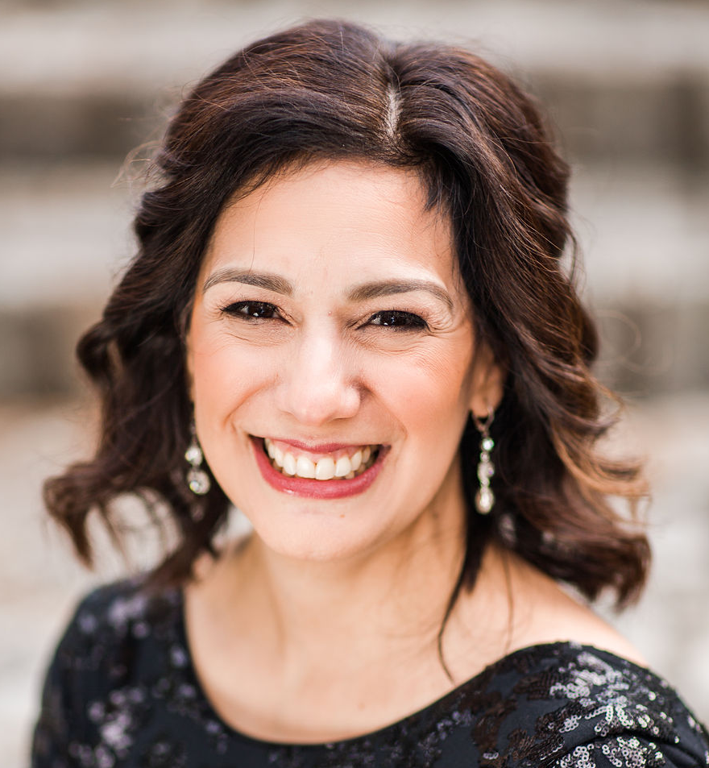
Michelle Norman, the 2020 Heroes at Home Military Spouse of the Year – Hampton Roads and the 2019 AFI Navy Spouse of the Year, is a Navy spouse of 25 years and mother of a 17-year-old daughter with cerebral palsy and multiple other disabilities. After years of successfully advocating and winning multiple legal cases to ensure her daughter receives the minimum education required by law, she was contacted by multiple military families across the country dealing with similar problems in public schools. Realizing that so many children will benefit from her dedicated efforts, the Virginia Beach resident has become a passionate advocate for military children with special needs and their families. Norman and four military spouses founded Partners in PROMISE, a grassroots advocacy organization focused on educating, advising and advocating for exceptional military families and their education.

Norman enacted change through persistent engagement with Congress and Virginia legislators. She successfully pushed for a study on military children and special education in the National Defense Authorization Act (NDAA) 2020. Norman continued raising awareness of education challenges faced by our military children through Congressional advocacy, to include her testifying to the 2020 HASC Military Personnel Subcommittee on Exceptional Family Member Program (EFMP) challenges and solutions, guest speaking during the 2019 Congressional Military Family Caucus Summit, and co-authoring the PROMISE Act (Protect the Rights Of Military Children in Special Education). The PROMISE Act Initiatives were incorporated in the recently introduced draft legislation bills H.R. 6395 and S. 4049 for the NDAA 2021.

On the DoD level, Norman is working to reform EFMP and is a key member of the Commander, Naval Region Mid-Atlantic (CNRMA) EFMP Support Team. Her efforts led to special education law training at the PELE - William & Mary Law Institute for Special Education Advocacy for over 140 military attorneys, paralegals and EFMP representatives across all services, an overhauled and much improved EFMP survey, and a US Navy EFMP pilot program to provide special education attorneys and liaisons to support and represent Navy children with needs. She also continues to teach parents, through town halls, workshops, webinars, and podcasts, about student’s educational rights.

Locally, Norman has enacted change by supporting bills that now help low income military families access an appropriate education. She also successfully partnered with Senator DeSteph on SB 41 which passed in the 2020 General Assembly. This Bill appointed two military spouses to the Virginia Council on the Interstate Compact on the Educational Opportunity for Military Children.

Norman serves on the Military Officers Association of America (MOAA) Currently Serving Spouse Advisory Council as well as a member of the Virginia Department of Education’s Military Student Support Process Action Team. Norman continues to lobby for stronger military spouse participation in organizations that have significant impact on our children’s education.

Norman currently lives in Virginia Beach, VA, with her husband Cassidy and daughter and son, ages 17 and 11. “My family believes strongly in doing the right thing, even when it is difficult. We are starting to make great progress for military families and it is my privilege to advocate and be a voice for our most vulnerable children,” she says.

